Proposed System

LoRa-Based Offline Communication and Safety System for Underground Mines
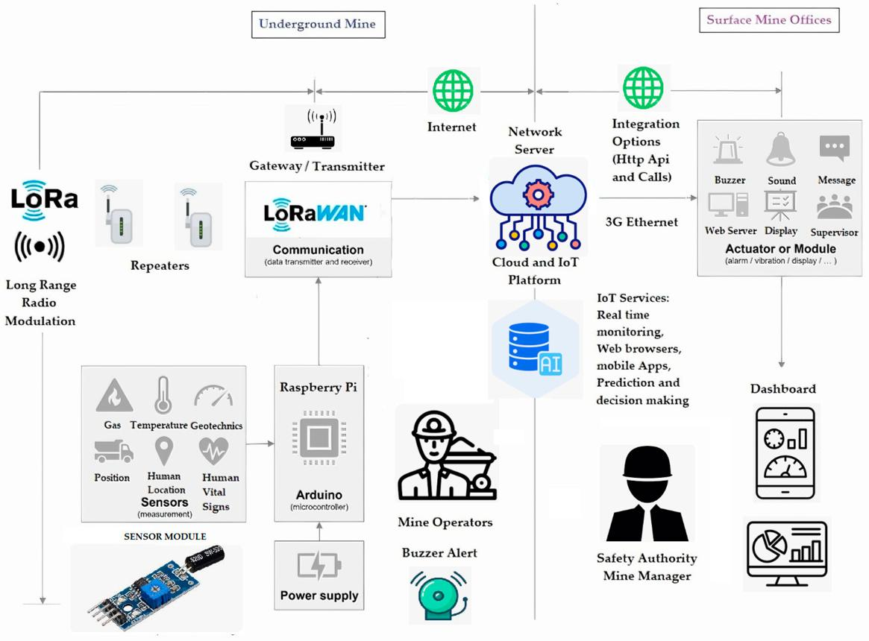
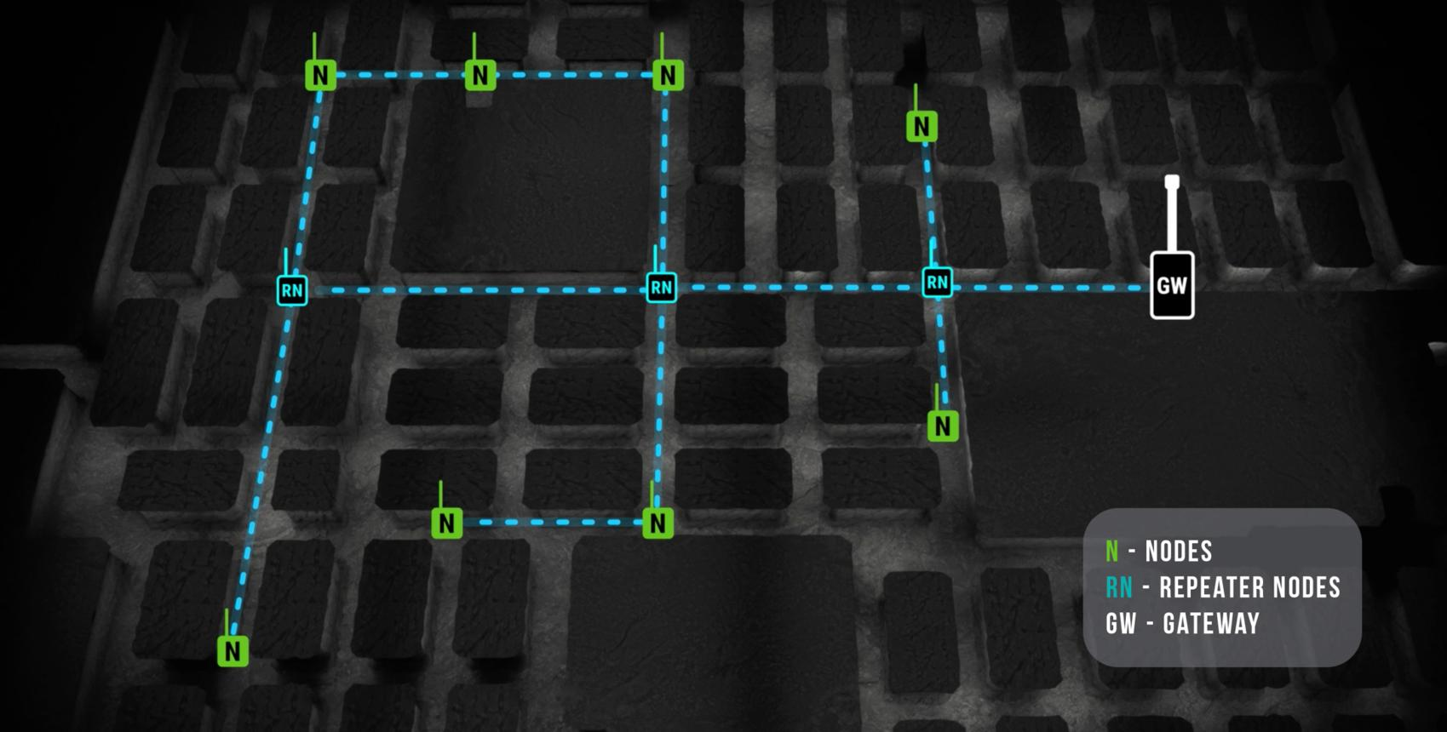
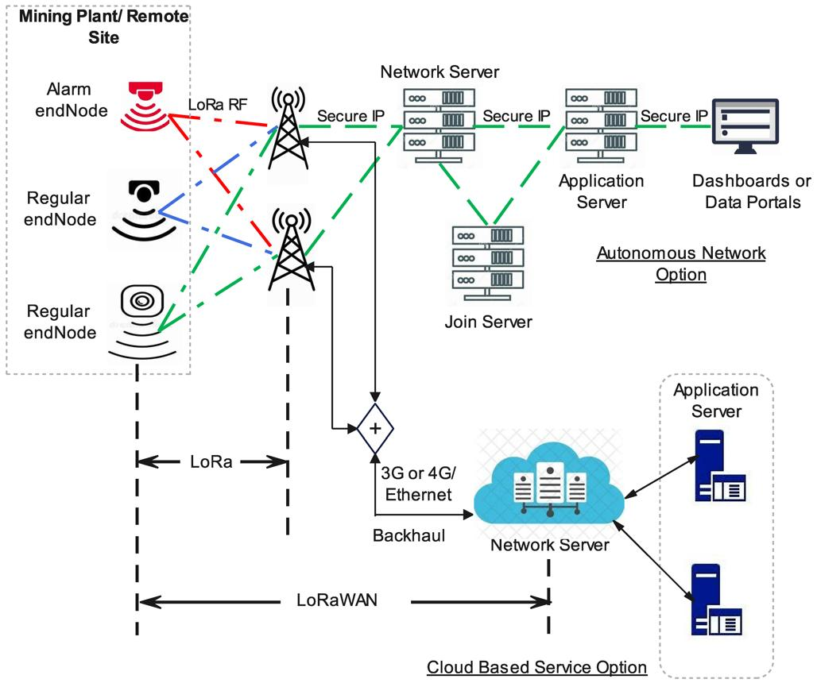
4

1. The Problem
Imagine an underground coal mine.
A worker goes 2 km underground.
His mobile phone shows:
❌ No Network
He cannot use:
- Mobile call
- WhatsApp
- Internet
- SMS
Now imagine an emergency.
For example:
Worker A falls down and cannot walk.
Or:
Gas level becomes dangerous.
Or:
Tunnel collapses and workers need help.
The control room may not immediately know:
- Who is in danger?
- Where is the worker?
- What happened?
- Is the worker able to communicate?
This is the main problem.

2. Proposed Solution
We create our own communication network inside the mine using LoRa nodes.
The system does not depend on Jio, Airtel, Wi-Fi or Internet inside the mine.
Instead:
Miner
↓
LoRa Device
↓
LoRa Node
↓
LoRa Node
↓
LoRa Gateway
↓
Control Room
The important idea is:
The mine itself becomes a communication network.

3. Overall Architecture
Here is the complete architecture in simple form:
SURFACE
┌─────────────────────────┐
│ CONTROL ROOM │
│ │
│ Computer / Dashboard │
│ Emergency Alarm │
│ Worker Information │
└────────────┬────────────┘
│
│
LoRa Gateway
│
│
===========================│========================
MINE
│
┌──────▼──────┐
│ LoRa Node 1 │
└──────┬──────┘
│
┌──────▼──────┐
│ LoRa Node 2 │
└──────┬──────┘
│
┌──────▼──────┐
│ LoRa Node 3 │
└──────┬──────┘
│
┌─────────────┴─────────────┐
│ │
┌─────▼─────┐ ┌─────▼─────┐
│ Miner A │ │ Miner B │
│ LoRa Unit │ │ LoRa Unit │
└───────────┘ └───────────┘

4. What Does Each Miner Carry?
Each worker can carry a small device.
For example:
┌──────────────────────────┐
│ MINER DEVICE │
│ │
│ ┌────────────────────┐ │
│ │ ESP32 / MCU │ │
│ └─────────┬──────────┘ │
│ │ │
│ ┌────▼─────┐ │
│ │ LoRa │ │
│ │ Module │ │
│ └──────────┘ │
│ │
│ 🔴 SOS Button │
│ 🔊 Buzzer │
│ 💡 LED │
│ 🌡 Temperature │
│ 💨 Gas Sensor │
│ 🔋 Battery │
└──────────────────────────┘
The device has a unique ID.
For example:
MINER-001
MINER-002
MINER-003
MINER-004

5. What Does a LoRa Node Do?
LoRa nodes are installed along the mine tunnel.
For example:
Entrance
│
│
Node 1
│
│ 500 m
│
Node 2
│
│ 500 m
│
Node 3
│
│ 500 m
│
Node 4
│
│
Mining Area
The nodes forward messages.
For example, Miner 004 is very far underground.
Instead of trying to communicate directly with the control room:
Miner 004
↓
Node 4
↓
Node 3
↓
Node 2
↓
Node 1
↓
Gateway
↓
Control Room
This is the multi-hop communication concept.

6. Example 1 — Normal Message
Suppose Miner 001 wants to send:
"I need assistance."
The miner presses a button.
His device creates:
ID = MINER-001
MESSAGE = NEED_ASSISTANCE
TIME = 10:32
The LoRa device transmits it.
Miner 001
↓
LoRa Node
↓
LoRa Node
↓
Gateway
↓
Control Room
The control-room dashboard displays:
⚠ ALERT

Worker: MINER-001
Message: NEED ASSISTANCE
Time: 10:32
Last Node: NODE-07
Status: ACTIVE

7. Example 2 — Emergency SOS
This is one of the most important applications.
Imagine a worker is injured.
He presses:
SOS
His device immediately sends:
SOS
Miner ID: MINER-003
The network forwards it:
MINER-003
↓
NODE-12
↓
NODE-11
↓
NODE-10
↓
GATEWAY
↓
CONTROL ROOM
Control room receives:
🚨 EMERGENCY 🚨

Worker ID : MINER-003
Status : SOS
Last Node : NODE-12
Time : 11:43
An alarm can automatically start.

8. Example 3 — Gas Detection
Now let's make the system more useful.
Put sensors on the miner device or fixed nodes.
For example:
Gas Sensor
↓
ESP32
↓
LoRa
↓
Network
↓
Control Room
Suppose methane becomes high.
The device sends:
MINER-003

CH4 = HIGH
Temperature = 39°C
Humidity = 81%
Control room:
⚠ WARNING

Location : NODE-12
CH4 : HIGH
Workers : 6

ACTION REQUIRED

9. Example 4 — Worker Status
The system can periodically send a small heartbeat.
For example, every 30 seconds:
MINER-001 → ALIVE
MINER-002 → ALIVE
MINER-003 → ALIVE
The dashboard could show:
Worker | Status | Last Seen
Miner 001 | 🟢 Active | 5 sec ago
Miner 002 | 🟢 Active | 12 sec ago
Miner 003 | 🔴 No Signal | 2 min ago
Miner 004 | 🟢 Active | 8 sec ago
If Miner 003 stops communicating, the system can raise an alert.

10. How Do We Know the Worker's Approximate Location?
This is an important point.
LoRa itself doesn't automatically give highly accurate indoor location.
Instead, we can use the last LoRa node that received the miner's message.
For example:
Entrance
│
Node 01
│
Node 02
│
Node 03 ← Miner 004 detected here
│
Node 04
│
Mining Area
The dashboard says:
Miner 004 — Last known location: Node 03
This gives zone-level location, not necessarily exact coordinates.

11. Complete System Architecture
We can divide the system into 5 layers.
┌─────────────────────────────────────────┐
│ APPLICATION LAYER │
│ │
│ Dashboard / Alerts / Reports │
└────────────────────┬────────────────────┘
│
┌────────────────────▼────────────────────┐
│ SERVER LAYER │
│ │
│ Database / API / Alert Engine │
└────────────────────┬────────────────────┘
│
┌────────────────────▼────────────────────┐
│ COMMUNICATION LAYER │
│ │
│ LoRa Gateway / LoRa Nodes / Mesh │
└────────────────────┬────────────────────┘
│
┌────────────────────▼────────────────────┐
│ DEVICE LAYER │
│ │
│ ESP32 + LoRa + SOS + Sensors │
└────────────────────┬────────────────────┘
│
┌────────────────────▼────────────────────┐
│ MINING ENVIRONMENT │
│ │
│ Workers / Tunnels / Machinery / Gas │
└─────────────────────────────────────────┘

12. What Happens From Start to End?
Let's follow one complete example.

Step 1 — Worker enters mine
Worker receives:
MINER-001
device.

Step 2 — Device starts
It registers itself:
MINER-001
Battery: 95%
Status: ACTIVE

Step 3 — Worker moves underground
The device communicates with the nearest LoRa node.
MINER-001
↓
NODE-01

Step 4 — Worker goes deeper
Now:
MINER-001
↓
NODE-02
The system updates:
Last known location = NODE-02

Step 5 — Worker reaches mining area
MINER-001
↓
NODE-03
Dashboard:
MINER-001
Location: Zone 3
Status: Active
Battery: 78%

Step 6 — Emergency happens
Worker presses SOS.
SOS BUTTON
↓
ESP32
↓
LoRa
↓
NODE-03
↓
NODE-02
↓
NODE-01
↓
GATEWAY

Step 7 — Control room receives alert
🚨 SOS ALERT

Worker: MINER-001
Last Location: NODE-03
Battery: 78%
Time: 14:32

Step 8 — Control room responds
The operator can send:
"Help is coming."
The message travels back:
Control Room
↓
Gateway
↓
Node 1
↓
Node 2
↓
Node 3
↓
Miner 001
The miner's device:
🔊 HELP TEAM NOTIFIED

13. What Can the System Communicate?
Don't initially try to send video or normal internet traffic.
LoRa is best for small packets.
For example:
SOS
HELP
OK
EVACUATE
GAS HIGH
TEMP HIGH
BATTERY LOW
I AM SAFE
You could also implement predefined buttons:
┌─────────────────┐
│ 🆘 SOS │
│ │
│ HELP │
│ │
│ OK │
│ │
│ EVACUATE │
│ │
│ MEDICAL │
└─────────────────┘
This makes the system extremely simple for miners.

14. Control Room
The control room can have a web dashboard.
For example:
========================================
MINE SAFETY MONITORING
========================================

Workers: 48

🟢 Active 44
🟡 Warning 3
🔴 Emergency 1

----------------------------------------

Worker Zone Battery Status

001 Zone 2 82% 🟢
002 Zone 4 91% 🟢
003 Zone 7 64% 🟡
004 Zone 8 77% 🔴 SOS

----------------------------------------

🚨 EMERGENCY ALERT 🚨

Worker 004
Zone 8
SOS ACTIVATED
========================================

15. Important: Does It Need Internet?
Inside the mine: No.
The LoRa network operates independently.
However, the control-room computer can optionally have Internet.
So:
INTERNET
│
│ optional
▼
Control Room
│
LoRa Gateway
│
═══════════════════
MINE NETWORK
═══════════════════
Even if Internet goes down, the local mine communication system can continue operating if designed with local processing/storage.

16. Recommended Prototype Hardware
For an academic prototype, a relatively simple setup could be:

Miner unit
- ESP32
- LoRa module
- SOS push button
- Buzzer
- OLED display
- Battery
- Optional gas/temperature sensors

Fixed node
- ESP32
- LoRa module
- Antenna
- Battery or mains/backup power
- Weather/enclosure protection

Gateway
- Raspberry Pi
- LoRa concentrator/gateway
- Local database
- Web dashboard
Conceptually:
MINER DEVICE
ESP32 + LoRa
│
▼
┌─────────────┐
│ LoRa Nodes │
│ 1 2 3 4 │
└──────┬──────┘
│
▼
LoRa Gateway
│
▼
Raspberry Pi
│
┌───────┴───────┐
▼ ▼
Database Dashboard

17. One Important Correction to the Earlier Idea
I would not automatically call this a "LoRa mesh network."
There are different ways to design it.
A simple first prototype could use:
Miner → LoRa gateway
If the mine is too large/deep for that, we can investigate:
Miner → repeater/node → repeater/node → gateway
The exact network architecture should be selected after considering tunnel geometry, node spacing, radio propagation and regulatory requirements.
For a research thesis, this distinction is important.

18. Your Problem Statement
You could formulate the research problem approximately as:
Underground mining environments often suffer from unreliable or unavailable cellular communication, making conventional mobile-based communication unsuitable for maintaining continuous connectivity with workers. This communication gap can become particularly critical during emergencies, where rapid transmission of worker status, alerts and approximate location information is essential. Therefore, there is a need for an independent, low-power and reliable communication system capable of operating without dependence on commercial cellular networks or Internet connectivity.
Then your proposed solution:
This work proposes a LoRa-based underground communication and safety monitoring system that establishes an independent wireless communication infrastructure using miner-worn devices, strategically deployed LoRa nodes and a surface gateway. The system enables low-data-rate messaging, emergency SOS alerts, worker status monitoring and environmental safety information transmission between underground workers and the surface control room.

19. Research Contribution
If this is for a research paper/PhD/M.Tech project, don't make the contribution simply:
"We used LoRa."
That alone isn't very novel.
Instead, you could investigate:

A. Reliable communication
How does communication performance change with:
- tunnel length
- depth
- bends
- node spacing
- number of nodes

B. Emergency priority
Give SOS packets higher priority.
Normal message
↓
Priority = 1

Sensor data
↓
Priority = 2

SOS
↓
Priority = 10
Emergency messages get transmitted first.

C. Adaptive routing
If Node 4 fails:
Normal:

Node 4 → Node 3 → Node 2
System discovers another available route.

D. Energy efficiency
Nodes should operate for long periods using low-power techniques.

E. Worker safety
Combine:
Communication + monitoring + alerts + location/zone tracking
rather than building only a messaging system.

20. Final Concept in One Picture
SURFACE
┌──────────────────────────────────────────────────┐
│ │
│ CONTROL ROOM │
│ │
│ Dashboard Database Alarm │
│ │ │ │ │
│ └────────────┼──────────┘ │
│ │ │
│ LoRa Gateway │
└────────────────────────┼─────────────────────────┘
│
═════════════════════════╪══════════════════════════
│
MINE
│
┌──────▼──────┐
│ LoRa Node 1│
└──────┬──────┘
│
┌──────▼──────┐
│ LoRa Node 2│
└──────┬──────┘
│
┌───────────▼───────────┐
│ │
┌─────▼─────┐ ┌─────▼─────┐
│ Miner A │ │ Miner B │
│ │ │ │
│ ESP32 │ │ ESP32 │
│ LoRa │ │ LoRa │
│ SOS │ │ Sensors │
└────────────┘ └───────────┘
│
┌──────▼──────┐
│ LoRa Node 3│
└──────┬──────┘
│
┌──────▼──────┐
│ LoRa Node 4│
└─────────────┘
│
DEEP MINE

In one sentence:
Miner carries a LoRa device → nearby LoRa nodes carry the message through the mine → gateway receives it → control-room software identifies the miner, status, alert and last-known zone → control room can send a response back.

